OMP Execs

For Auto Dealers Programs For Business Seller
I want to build a hybrid platform with more power than OfferUp. Merge OfferUp and Dealer Essentials and now you have OMP Deals. Now on the Dealer Essentials platform which is a Auto Dealership platform we will apply those features/tools for VERIFIED BUSINESS ACCOUNTS.

[ White Label Feature ??]
https://www.dealeressential.com/
reverse Engineer this site [ https://www.dealeressential.com/ ] and include the features for the OMP Executive Account Menu Button

OMP Execs
OMP Executive Account – typically for managing Franchise Locations and Major Companies with multiple locations. Provides a Central Office Management feature where Executives or Business Owners can manage multiple locations and access data , reports and analytics. This feature will provide individual reporting and collective reporting for all accounts. Users can sign One, Multiple or All Location under an umbrella account and apply for individual licenses for each location to use the platform.

FEATURES

Dealer Essentials OMP Deals Name Title

Stock the Lot
VIN Scanner & Bookout Vehicle History Report (VHR)
Top VIN check sites include Bumper for comprehensive subscription-based data, Carfax for detailed history reports, VinAudit for NMVTIS-backed reports, and iSeeCars for free VIN checks and market value insights.

AI RealPrice™ Market Pricing AI Market Pricing (AIMP)
Research product pricing online from lowest, medium to highest so you can know what the Market is asking.
Top sites for auto title searches include the National Motor Vehicle Title Information System (NMVTIS), VinAudit, and EpicVIN. These platforms provide access to vehicle title history and related information.

DMV & Title Search Auto Lien & Title Search (ALTS)
Instantly check for liens and title brands before you buy. Avoid costly surprises.

Reconditioning Center Repair Order Management (ROM)
Track recon costs and vehicle status from purchase to the front line. Know your true cost.
Auto Repair Software & Inventory Management /
https://ari.app/
https://autoleap.com/
https://www.shopmonkey.io/

Guided Photography AI Photo Genius (AIPG)
Pro photos, every car, every time. Mobile app guides ensure your inventory looks its best online.

Dealer Essentials OMP Deals Name Title

Attract Buyers
Magic Lister AI Postmaster (AIPM)
AI creates your vehicle listings in seconds. Post to Facebook, Car Gurus, Auto Trader, Craiglist, Google Ads Google, Google Vehicle Ads & more with one click.
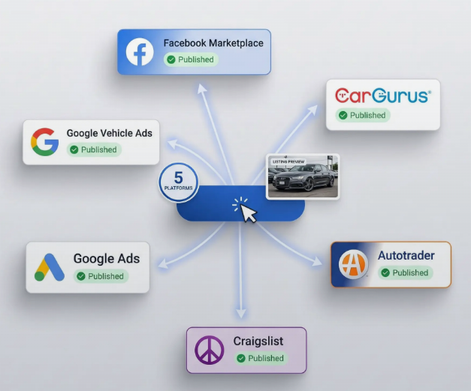

AI Background Editing AI Multiverse Backgrounds (AIMB)
Quickly eliminate cluttered backgrounds and select from 100 professional choices for your images.

Premium Dealer Website High-Quality Auto Website (HQAW)
A stunning, mobile-friendly website that turns visitors into leads. No coding needed.

Google Optimization AI Search Engine Optimization (AI SEO)
Show up first on Google. We manage your profile and reviews to attract more local buyers

4K Video Walkarounds Auto Video Live (AVL)
Film and share quality video to your social media platforms and mobile contacts of your inventory right from your phone.

Dealer Essentials OMP Deals Name Title

Work the Deal
Unified Inbox & CRM OMP Deals CRM
All your texts, emails, and messages from every platform in one simple, manageable inbox. Individuals can manage leads and save contacts into the CRM

AI Call Assistant AI Phone Receptionist
A 24/7 AI receptionist that answers every call and books appointments, so you never miss a lead.

Desking & Deal Calculator 60 Second Deal Offer
Create any cash, finance, or BHPH transaction in 60 seconds with accuracy and efficiency.
Customers focus on monthly payments, not the MSRP. First, determine what they can afford based on interest rate, term, down payment, and trade-in value to set the maximum vehicle price, show the right cars, and protect profit margins.
https://www.dealervlo.com/tools/deal-structuring-calculator
https://loturn.com/features/desking
https://leadlocate.com/sales-leads/desking-tool

Lender Marketplace Auto Loans Marketplace
Submit one credit application to all your lenders at once and get fast approvals.

E-Sign & Digital Docs Auto E - Business
Go 100% paperless. Securely sign and store all your documents in the cloud.

Dealer Essentials OMP Deals Name Title

Manage the Business
Central Office Management features where Executives or Business Owners can manage multiple locations and access data , reports and analytics. This feature will provide individual reporting and collective reporting for all accounts, and each location will require its own license to operate.
EXAMPLE: One a Business Signs Up and gets verified , they can either sign up with One Account and One License for One Location or
If the business is a franchise or a major corporation with multiple locations. They can sign up with One Account and the can register for a License for each location during the verification process. Or
That same company can choose to Sign Up for One Account for each individual location allowing each location to manage their individual account.

Profit Dashboard ROI Dashboard
See your exact net profit on every single vehicle sold, updated in real-time.

Expense Tracking Cost Management
Snap photos of receipts on the go. Link costs directly to a vehicle's stock number.

BHPH Management Suite
Manage your Buy Here Pay Here portfolio, track payments, and automate reminders.
https://www.dealercenter.com/buyherepayhere/
https://www.dealeressential.com/solutions/buy-here-pay-here-management-suite
DeskManager QuickBooks® interface includes the following features:
- Automatic late-fee processing
- Automatic recurring payment processing using credit card, debit card, and ACH
- Automatic buyer notifications on all automated transactions
- Payment date changes and modifications
- Support for multiple merchant accounts to differentiate debt repayment from other types of payment to support new regulations (Global Payments Integrated/OpenEdge)
- Detailed transactions, payment, and accounting history
- User-defined statuses to manage and flag your accounts based on the needs of your dealership
- Task generation, Notes, Conversation Logs, and Follow-Ups
- Side Notes and Adjustments
- Support for Related Finance Company (RFC)
- Extensive Reports and Charts
- Deferred Payment tracking
https://www.automanager.com/buy-here-pay-here/
Team Permissions Team Management
Add your entire team with custom roles. Control exactly who can see and do what.
Team permissions are the settings that control what users can do within a team, including roles like owner, member, and guest, which dictate their access and capabilities. These permissions help manage team creation, channel access, and file sharing, ensuring secure collaboration within an organization.
Modern Mobile Apps OMP App
Run your entire dealership from the palm of your hand with our iOS and Android apps. Office Management features where Executives or Business Owners can manage multiple locations and access data , reports and analytics. This feature will provide individual reporting and collective reporting for all accounts, and each location will require its own license to operate.
EXAMPLE:
One a Business Signs Up and gets verified , they can either sign up with One Account and One License for One Location or
If the business is a franchise or a major corporation with multiple locations. They can sign up with One Account and the can register for a License for each location during the verification process. Or
That same company can choose to Sign Up for One Account for each individual location allowing each location to manage their account.

OMP Executive Account – typically for managing Franchise Locations and Major Companies with multiple locations. Provides a Central Office Management feature where Executives or Business Owners can manage multiple locations and access data , reports and analytics. This feature will provide individual reporting and collective reporting for all accounts. Users can sign One, Multiple or All Location under an umbrella account and apply for individual licenses for each location to use the platform.

